Persistence Length

Madilyn Paul

The persistence length of a polymer is used to describe the polymer's rigidness. This is a mechanical property that plays a large roll in the way polymers interact and self-assemble into given morphologies. In this study we determined the persistence length for a set of polymers with OPV properties. The morphology that OPV polymers self-assemble into has a significant impact on the efficiency of the OPV devices that are made from these materials. Currently, it is not understood how certain morphologies increase the efficiency or how to obtain the more efficient morphologies. Being able to draw a connection between the physical and/or chemical properties of polymers to higher efficiency morphologies allows us to discover new materials that would increase the power conversion efficiency (PCE) of OPV devices.

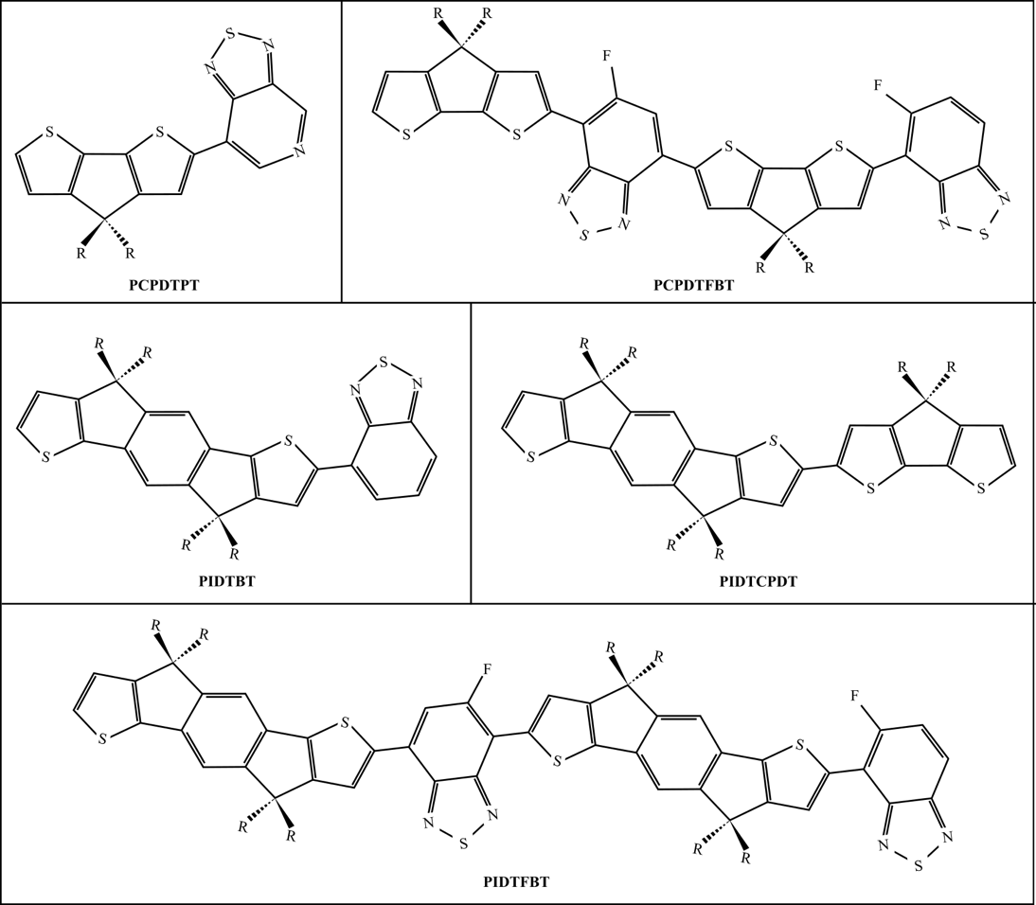

The monomers we investigated in this study are shown in Figure XX, along with the r-groups in Figure XX.

Materials and Methods

Molecular Dynamics

In this study, we conducted molecular dynamics simulations using HOOMD-Blue and graphical processing units to investigate the persistence length of various polymers. Each simulation was conducted in the canonical ensemble (NVT), in which the number of particles, volume, and temperature are all held constant throughout the simulation. Particle positions and velocities were updated using a two-step velocity-verlet integration of Newton’s laws of classical mechanics. The Flower-MD software package was utilized to construct our simulation object and initialize the simulations. All simulations were initialized using the Pack functionality, in which the particles are places randomly in a cubic simulation box with periodic boundary conditions enforced. The simulation box size is calculated from the desired density, which is listed in Table XX for each polymer. Thirteen conjugated polymers with similar backbone structures and varying side chain lengths were simulated in this study. For each simulation we initialized a polymer of 250 monomer units in a large simulation space. Simulations were conducted at temperatures of 2, 4, 8, 10, 12, 14, and 16 kT to capture how the persistence lengths evolve with temperature. Simulations were run for 5 * 10^7 timesteps.

In this study we utilized molecular dynamics simulations to investigate the persistence length of various complex polymers with photovoltaic properties. We employed In order to investigate the persistence length of these polymers we first built our polymer fragments using SMILES strings. Using mBuild we created our monomers using the force_overlap functionality to connect the molecule fragments. The espaloma software, which we validated for use on OPV molecules in Chapter XX, was employed to parameterize and create forcefield for each of the polymers. To account for the polymerization bonds, we parameterize both dimers and monomers using espaloma to ensure there are no missing forcefield parameters. The polymers in this study were built using the mBuild polymer class. Polymers made up of 250 monomer units were initialized

Results:

* We see differences in l_p with side chains, but we don’t see any trends
* Our values are similar, but not exact
* We see bendier polymers, but that could be because we don’t have anything else in a system with the polymer, so it can only interact with itself
* We observe that all the polymers persistence length plateaus at ~8-10 kT